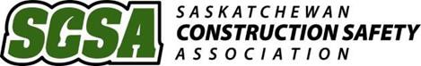

Worksite Safety Inspection

Company Name: |  | Date: |  | Time: |  | AM PM
Inspection Conducted by:  (Supervisor, worker(s) & OHC should be involved) |  | Area(s) Inspected:
 |  | Site Address:

Deficiencies and Corrective Actions
Priority Index
Severity 1. Imminent Danger 2. Serious 3. Minor 4. Negligible/Ok 5. Not Applicable
Probability A – Probable B – Reasonably probable C – Remote D – Extremely Remote
Deficiency Identified |  | Priority Ranking | Corrective Actions Required |  |  | Action Assigned to | Completion
 |  |  |  |  |  |  | Date | Time
Supervisor Review:  (Print & Sign) |  |  |  | Date:
Management Review:  (Print & Sign) |  |  |  | Date:
Comments:
*Inspections are typically conducted while work is being performed. When completing inspections include: verifying compliance within your company’s safety program, identifying unsafe acts or conditions, and adherence to applicable Legislation.

For more information on your legal obligations regarding worksite safety please contact us.
Contact us by email at: SCSAINFO@SCSAONLINE.CA or Toll Free at 1.800.817.2079

