Company: |  |  |  | Date & Time: |  |  |  | AM /PM | Project:
Location: |  |  |  | Task: |  |  |  |  | Muster Point:
Including address where possible
Complete the Hazard Assessment at the task location prior to the start of work and update when conditions change.
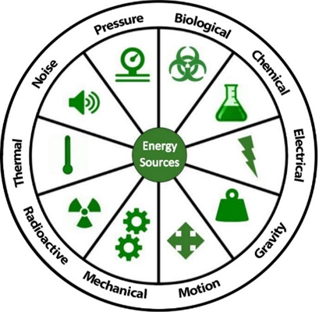  Radioactive: (UV rays, welding arcs, x-rays) |  |  | Biological: (animals, insects, contamination)  Gravity: (falling objects, slip/trip/falls, open holes)  Thermal: (heat, cold, burns) |  |  |  | Chemical: (flammable, corrosive, toxic materials)  Motion: (swinging objects, moving equipment/objects/ parts)  Noise: (above 85 dBA, loud machinery, vibrations) |  |  |  | Electrical: (damaged cords, overhead power lines, overloaded circuits)  Mechanical: (Rotating parts, pinch points, sharp edges)  Pressure: (stored energy, mechanical tension, explosions)

PRIORITY INDEX |  |  | Permits & Plans: |  |  |  |  |  | Performing Critical Tasks?  Yes No
Probability | Severity
- Very Likely | - Major Incident/Fatality |  | Fall Protection Plan |  |  | Lockout/Tagout Permit |  |  | SWP/SJP Reviewed:
- Possible/Likely | - Medical Aid/Lost Time |  | Critical Lift Plan |  |  | Hotwork Permit
- Unlikely | - First Aid/Near Miss |  | Confined Space Permit |  |  | Scaffold Inspected
Identify and prioritize the hazards below according to Severity and Probability using a combined risk rating, i.e.) 1A, 2C, etc.
Tasks | Hazards  (Existing & Potential) |  |  | Priority Ranking | Control Required  (Provide description) |  | Person Implementing Control |  |  | Completed
 |  |  |  |  |  |  |  |  |  | Date | Time
 |  |  |  |  | 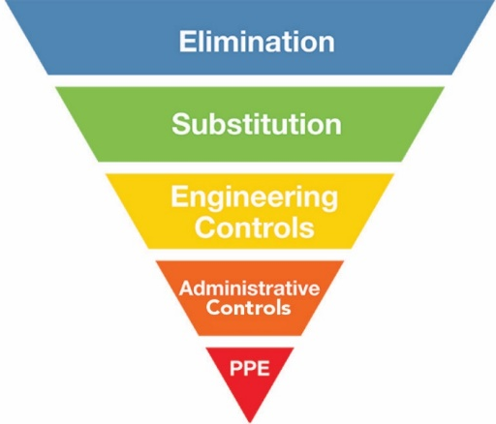
Workers Participation in Hazard Assessment: |  |  |  |  |  | All PPE has been inspected before use & in good condition? Yes No
Print Name/Initial |  | Print Name/Initial |  |  |  | Hazards Reviewed & Reassessed at:
Print Name/Initial |  | Print Name/Initial |  |  |  | Time:
Print Name/Initial |  | Print Name/Initial |  |  |  | Time:
Print Name/Initial |  | Print Name/Initial |  |  |  | Time:
Print Name/Initial |  | Print Name/Initial |  |  |  | Time:
Supervisor Review: | Print Name/Signature |  |  |  |  | Date & Time: |  | Supervisor Review
v4.0 29-Oct-25

